Internet Deployment System for Distributed Training

By: Jihad Ibrahim
Lana Wreikat

Computer & Communications Systems Co.

Tel.: 962 6 5344088
Fax: 962 6 5346494
P.O. Box: 950499 Amman, 11195 Jordan

INTERNET DEPLOYMENT SYSTEM

Training Purposes

DEFINITION

INTERNET/INTRANET SOFTWARE ENVIRONMENT FOR HOSTING ALL DISTANCE TRAINING/LEARNING ACTIVITIES

DISTANCE TRAINING/LEARNING ACTIVITIES

- PRESENTATION

- SIMULATION

- AUTHORING / EDITING

- INTERACTION / COMMUNICATION

- EVALUATION

- REGISTRATION

- MONITORING

- RESOURCES

ENVIRONMENT

- LOCAL

- DISTRIBUTED

- SUPERVISED

- FREE

DEPLOYMENT ELEMENTS

- INTERNET ACCESS

- WEB ENABLED APPLICATION

- CONTENT INDEPENDENT INTERFACE

- MULTIMEDIA TOOLS (PRESENTATION, SIMMULATION)

- HTML/XML AUTHORING TOOLS

- VIDEO STREAMING

- WHITE BOARD, CHAT, EMAIL

- COLLABORATION/ SCREEN CONTROL

- AUTOMATIC TESTING AND GRADING

- TRACKING

- REGITRATION

- SECURITY

IMPLEMENTATION

- Insure Internet access for users

- Identify proper learning environment

- Identify learning material and resources

- Use deployment system authoring tools to load learning material. The training material should be instructionally designed for distributed learning.

- Use available multimedia tools for creating audio/ video effects.

- Identify interactive and engaged learning elements and prepare the appropriate communication environment and software layout.

- Create evaluation and testing sheets.

- Use registration system to enlist systems users.

- Depending on learning environment, conduct training course

Internet Deployment System

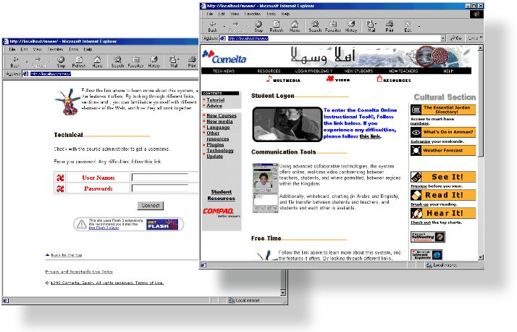

We are pleased to propose a dedicated, open-architecture, instructor-led training and structured learning environment for the deployment of student-courses and other related educational content.

This is an entirely Web-based delivery system, designed either to work in assisting independent student development, or to complement live classes in a traditional teacher/student model. As a result, the system requires minimal technical expertise on the part of the developer of the course, and on the part of the student.

The system is designed to produce a rich learning environment with full multilingual capabilities, based on teacher assigned and supervised classes. Also, to assist in the learning process, the student Graphical User Interface is the standard web browser (optimized as Microsoft Internet Explorer 5.0), allowing all media, courses and other resources to be accessed through one common, unified and familiar interface.

Class Management

Class lists are entered through the integrated student management system where students are assigned to courses, and to the classes within those courses. As an integrated part of this system, students then access online documentation and course materials through a standard Internet/Intranet web browser. They would then have access to coursework and a variety of communication tools allowing real-time communication and collaboration between others students, and the teachers and supervisors in charge.

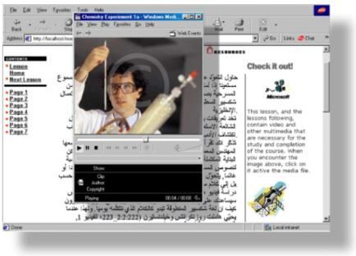
Course Designers may imbed video, multimedia, and other external resources into pages of Web Courses. This allows for a rich and rewarding environment for students to interact with.

In addition, using supplied tools, coursework may be personalized for individual students by their teachers by customizing courses to include any Web-compatible materials that can aid in learning: this can include "new technologies" (streaming media and simulations), links to external resources, including video, text books, journals, etc..., and can be adapted to new resources as they become available.

Most question types can be automatically graded. Comprehensive statistics are available for quiz and question performance. A completed quiz is available to be marked on-line. Once marked, the grade assigned is automatically entered into the grade database and, along with comments, made available to the student.

The system supports on-line testing and assessments, including essay responses to questions that can be routed directly to instructors, and the setting of multiple choice tests which are automatically graded by the system. The multiple choice questions may be presented with either a single or several correct answers, and other features.
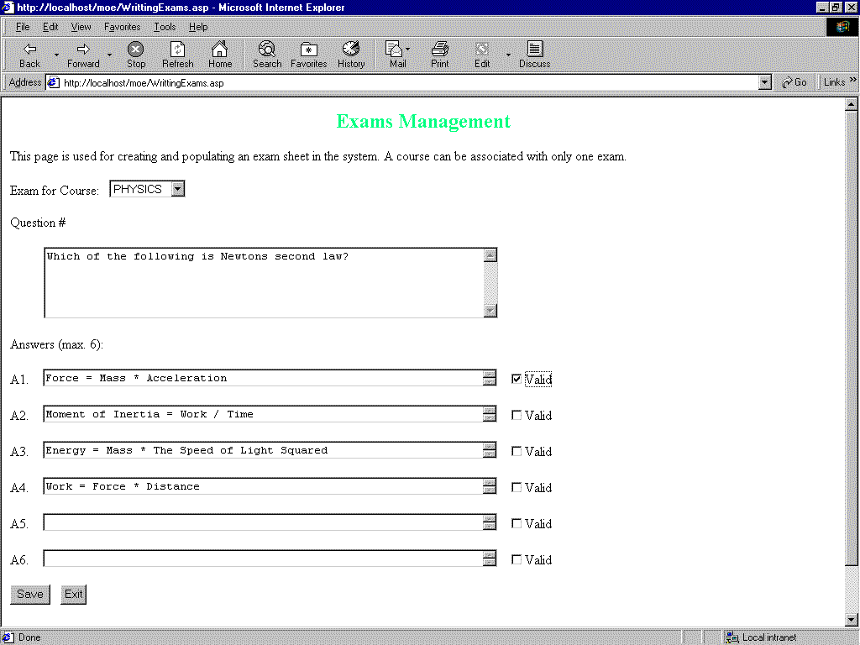
This interface shows the teacher controlled “Exams Management” screen, that allows the creation on sophisticated tests and quizzes that may be distributed to students within minutes. The intuitive design allows easy accessibility for even novice users.

Tests can be built “on-the-fly” by teachers, using an integrated interface that is itself accessed through the common Web browser. Once logged on, teachers are able to define new tests associated with courses, and to enter both questions and answers, and to verify the output. All these common functions may be performed with only a few hours training, and the intuitive interfaces are both self-explanatory, and able to be used by individuals with little or no technical background.

Once tests are completed, instructors can request that the system redisplay all multiple choice questions answered given by each student, the correct answer sought, and the actual answer sought compared to the answer given.

As part of the system's dedicated interface for communication and collaboration within courses, discussion lists provide many features including moderated discussion, threading and file attachments. Navigation is simplified, and students may send messages, in context, to their instructor at any point. This is designed to assist both the student in the act of communicating and learning, and the instructor in act of providing and supervising an educational environment.

As an independent module, chat rooms, their names, and a list of course participants in each room would be used in the system. The list of users in each chat area is available. Most of the chat rooms are exclusive to students in that course, but there is also one general chat room that allows communication among students in any course on the same server.

Progress tracking would monitor students through each course. Indicators such as date and time of start of course, and other data would be collected. An indication of course participation by way of a Teacher's only Web interface is also available directly, and in real-time.

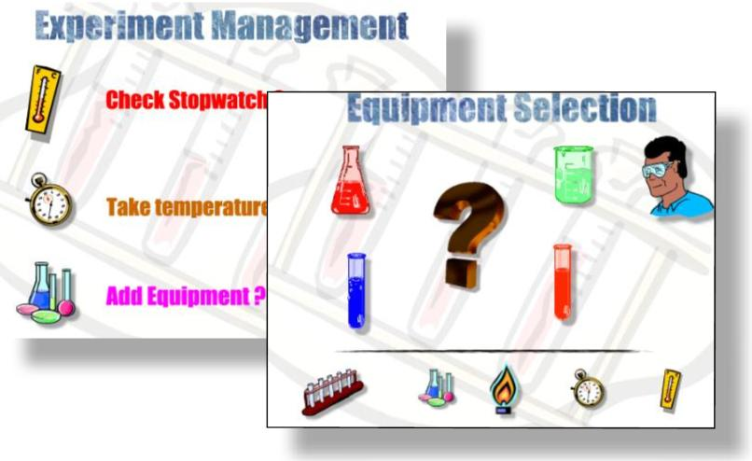
By deploying state-of-the-art interfaces integrated with the course management tool, emerging technologies may be incorporated as they become available.
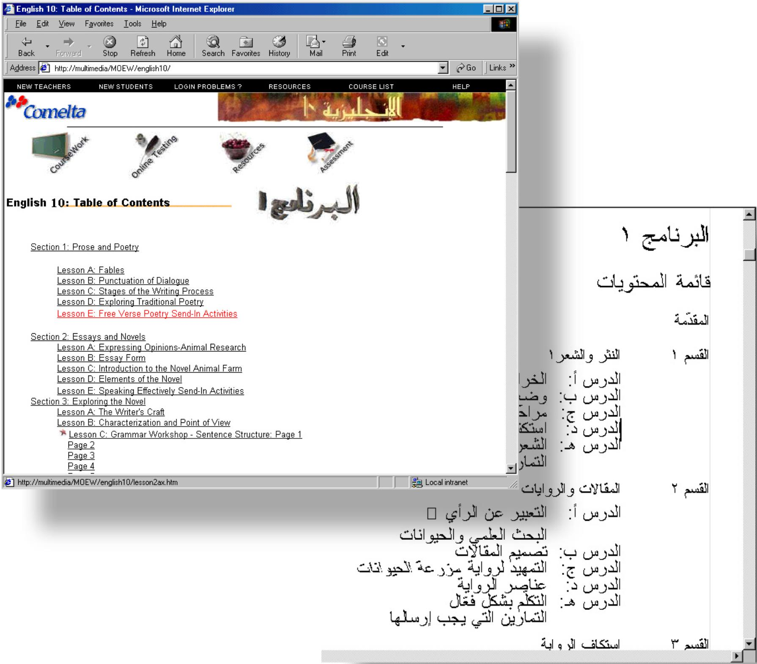

Student movement is monitored throughout the course lessons. Multilingual interfaces are an integral part of the Web capabilities, allowing easy accessibility for students of all levels.

Students are able to return to a course that has been previously started, or to produce reports about the state of a course completed or classes covered. The system is also able to prevent students accessing courses or other resources that they are unauthorized to enter.

Other progress tracking is available which indicates the total number of accesses. This can be used to make references about the level of interest or difficulty of a page. Moreover, full auditing features can be incorporated into the system depending on teacher preference and curriculum requirements.

Security levels are installed to restrict access to inappropriate courses and other materials. Access to the system will only be given to those with course accounts, and this can be modified either by the system administrator, or by an authorized instructor in the case of class management.
The English10 Course is an example of a fully integrated Arabic language course, delivered across the educational Intranet.

The course includes quizzes, interactive elements, as well as external resources, including books, video and multimedia.

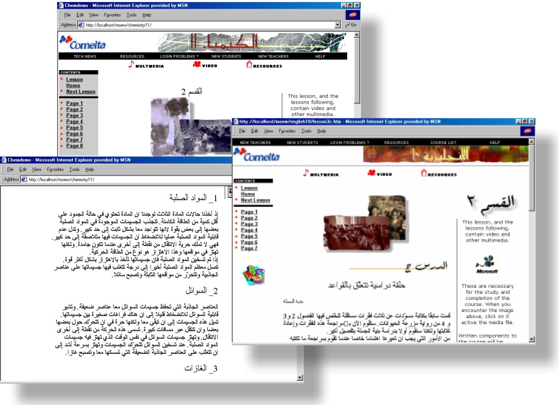

Technology

Designed using a standardized Microsoft DCOM and COM system architecture, the system is fully compliant with all current W3 Commission standards for Web technology utilization. Development tools include Microsoft Visual InterDev, Microsoft Office 2000, SQLServer 7.0, and Active Server Pages technology, with Frontpage 2000 Server Extensions, running on either IIS 3.0 or IIS 4.0 on a Windows NT 4.0 Server platform.

Deploying a combination of XML, ActiveX, HTML, and DHTML, with existing interfaces for new communication and collaborative tools in place. The system can easily adapt to emerging technologies, and the incorporation of new media as necessary in the future.

All system files are built using Microsoft ASP technology, to allow complex database queries and system operations on the server side whilst still maintaining the highest standards of system design, maintenance and security. A single, established vendor was deliberately sought, and employed in the system development: this resulted in a unified, integrated and highly stable tool for the deployment of student courses and curricula.
Creating Learning Modules
- Any topic expert can create course content using popular tools like PowerPoint and Word
- Pull existing instructor-led course content into the system and organize it into classes with tests
- Use any of the popular authoring tools to create media rich content
- Import large quantities of existing content using automated batch processing
- Reuse content in other courses

Testing and Measurement
- Create reusable test questions and group them into logical pools
- Build banks of tests that can be assigned randomly to different users
- Course materials presented to an individual user can be modified on the fly based on test results.
- Automated grading of tests
- Extensive reporting on individuals, content viewing, and test effectiveness
- Feed test results and class progress into any 3rd party application package

Deployment
- Access courses easily with any standard web browser, no plug-ins are required
- Search through all course materials for information
- Complete facilities for registering and certifying users
- Provides complete security over access to course content and tests

Collaboration Tools
- Provides easy access to experts while learning new topics
- Access "hot-lines" for rapid answers to technical questions
- Threaded discussion groups provide an on-going resource for new information
- Subject experts can be assigned to groups taking courses

Group Class Management

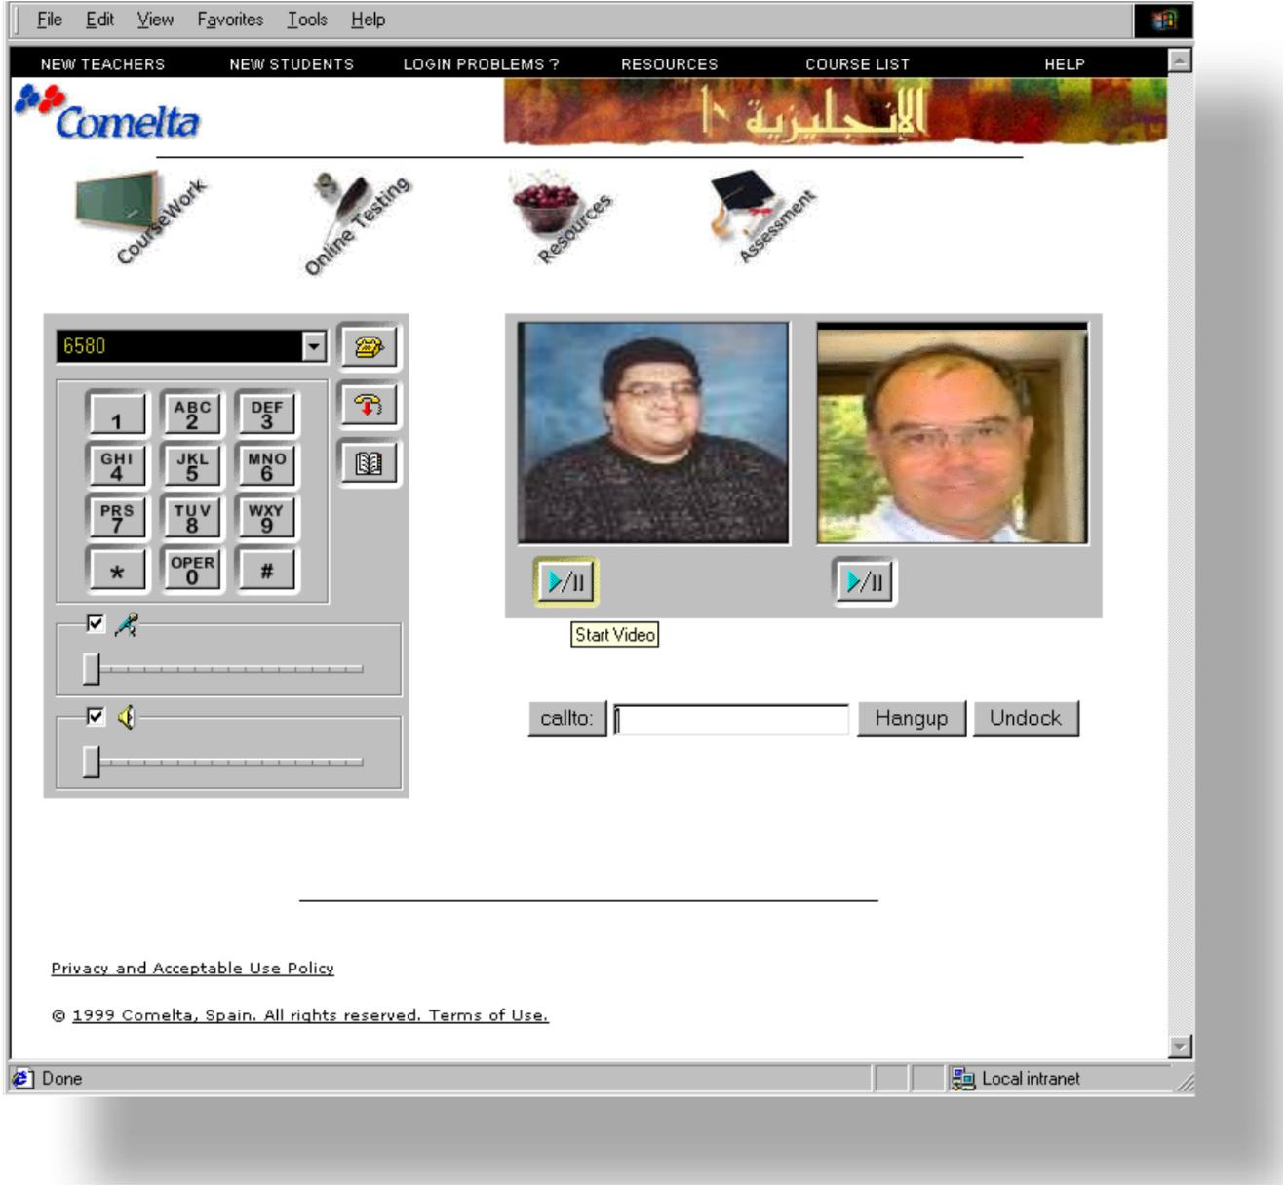
By integrating class management with groupware tools, file and application sharing become an indespensible part of class setup.

The H.323 standard allows the widest possible standards utilisation to allow for future technologies, including video conferencing should the need arise.

Support for class management allows the teacher and students within the class to communicate and collaborate as a group in real-time over the classroom network. This solution enables users to work together by sharing applications, exchanging information through a shared clipboard, transferring files, collaborating on a shared whiteboard, and communicating with an English/Arabic text-based chat feature. Also, support for the T.120 data conferencing standard, and additional, optional support for the H.323 Video conferencing standard enables interoperability with other T.120-based products and services. The following features comprise multipoint data conferencing:

- Teaching tool. Teachers can project their screen, in real-time, to all participants within a class simultaneously. This allows easy demonstration of live course and computer concepts, and also provides immediate feedback within the classroom, at the teachers' discretion. Through the same intuitive interface and tool, the teacher can view students' screens, and monitor activity and progress in an immediate and personal environment.
- Application sharing. Class participants can share a program running on one computer with other participants in the class. Participants can review the same data or information, and see the actions as the person sharing the application works on the program (for example, editing content or scrolling through information.) Participants can share Windows-based applications transparently without any special knowledge of the application capabilities.
The person sharing the application can choose to collaborate with other conference participants, and they can take turns editing or controlling the application. Only the person sharing the program needs to have the given application installed on their computer.
- Shared clipboard. The shared clipboard enables the exchanging of contents with other participants in a class using familiar cut, copy, and paste operations. For example, information can be copied from a local document and pasted into a shared application as part of a group collaboration. This capability provides seamless exchange of information between shared applications and local applications.
- File transfer. With the file transfer capability, a file can be sent in the background to one or all of the class participants. The file transfer occurs in the background as everyone continues sharing an application, using the whiteboard, chatting, or following the computer based courses independently. This file transfer capability is fully compliant with the T.127 standard.
- Whiteboard. The whiteboard program is a multi-page, multi-user drawing application that enables sketching diagrams, organization of charts, or display of other graphic information with people in a class. Whiteboard is object-oriented (versus pixel-oriented), allowing users to move and manipulate the contents by clicking and dragging with the mouse. In addition, you can use a remote pointer or highlighting tool to point out specific contents or sections of shared pages. This capability extends the application-sharing feature of by supporting ad hoc collaboration on a common drawing surface.
- Chat. A user can type text messages to share common ideas or topics with other class participants, or record meeting notes and action items as part of a collaborative process. A "whisper" feature lets teachers and students have a separate, private conversation with a student during a group chat session.

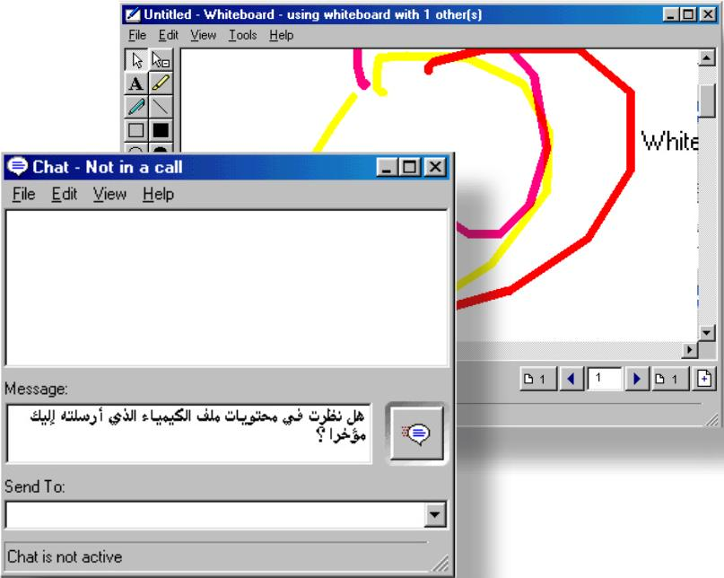
Collaborative tools, including a suite of Whiteboard, text chat, file sharing, and application sharing, allow instructors to oversee student activity, student to work together, or complete control of student systems.

All of this occurs within a native Web-environment, and included full support for Arabic.

Frontpad, HTML editor

We include in our feature-rich HTML editor which can be a handy tool for Web page creation.

This integrated HTML authoring tool, which is accessible from the standard Web browser, features a toolbar with all of the features for users to generate WYSIWYG Web pages that is familiar in look and feel to the suite of standard editing and authoring tools.

FrontPad includes a Personal Home Page Wizard, which includes page templates that makes designing Web pages very accessible to people without previous experience in coding with HTML. A good set of tools for beginners, this also includes the added advantage that it also provides support for Java, JavaScript, and, of course, ActiveX. By allowing the creation and editing of forms and tables, it makes this an ideal authoring companion even for experienced users.
Internet Explorer 4.0 bundles FrontPad allows for simultaneous editing and Web creation, as well as browsing and inspecting finished documents, from the same familiar interface.
FrontPad includes moveable toolbars for forms, formatting, and even for adding custom search scripts.

Astound Dynamite 1.1: Multimedia Authoring

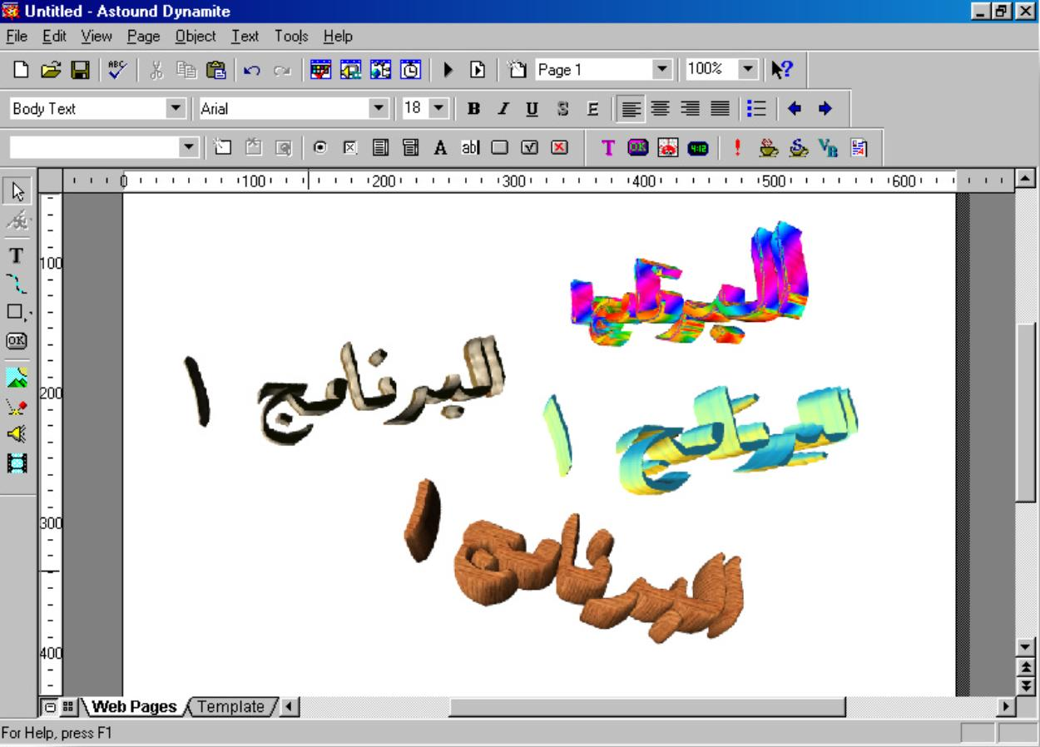

This tool allows any user to easily organize, powerfully illustrate, and professionally deliver ideas and concepts in a versatile multimedia format, through a Web deployment interface if required, using familiar and easy to operate tools and interfaces.
Working as an integrated suite of tools, this allows teachers and other users to create full Internet and Web delivered Mulitmedia. In addition, it's easy-master-features allow full system development without any previous programming or technical experience, or the need to learn confusing code or complex commands. It is a powerful, easy-to-use, authoring program designed specifically for creating powerful graphics, Web-elements, animation, and interactivity by simply assembling ready-made components in an intuitive and easy-to-learn WYSIWYG graphical interface.
Once pages have been created, the powerful Publishing Wizard automatically outputs in both DHTML and standard HTML. Projects can then be viewed in the standard Web browers (for example Microsoft Internet Explorer), without any additional plugins or downloadable components.

Full support for Java and ActiveX
Although this is an ideal instructional tool for inexperienced users to create media-rich web pages, more sophisticated authors will also be allowed to use newer, complex technologies, including Dynamic HTML, Java, Javascript, ActiveX controls, or VBScripts in the creation of their Web pages. Robust animation of objects and text is also allowed: methods for creating them are as simple as a point-and-click path animation tool or through transitions (over 30 effects are included).
Multimedia creators can assure that objects (buttons, portions of animation, video, etc.) on each page can interact with each other, and with viewers.

Enhanced Interactivity
Further, this solution goes beyond traditional Hyperlinking by allowing the creation of Dynamic Buttons that respond to user actions, interactively control other objects for complex menu effects, and trigger sound, video, and animation.

Sophisticated Graphics, Audio and Video
Authoring is either done by building new projects, or by adapting one of the many templated already included. Furthermore, some projects may require the collaborative efforts of many different creators, all within the school jurisdiction (but who may work from diverse disciplines/regions). In order to assure the production of documents and projects to the same standard, new templates themselves can be created and distributed to all contributors on a project.

By allowing precise control over formatting, fonts, and layout, this solution allows the following features: 25 different drawing tools, plus the ability to import and manipulate a wide variety of graphics and media formats including GIF, JPG, PICT, WMF, TIF and others.

As a high level design tool, pages can also be made to include audio and video additions for teaching complex subjects. This proposed solution supports all the major audio and video formats including WAV, MIDI, RealAudio, RealVideo, MPEG, AVI and Quicktime.

Rich animation and precise timeline synchronization
The free-form path animation tools and unique Timeline Window allow the animation of any object with complete control over its entry, pause, and exit times.

